Khangai Herds 1- Saikhanaa the Herder

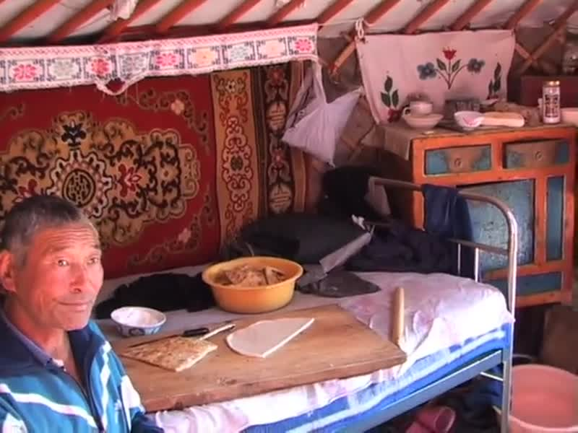

### identifier

d36f0687-e8a3-46e8-ba99-63bb3cd33ae9

### creator

Fijn, Natasha

### type

Moving Image

### coverage

Mongolia

### description

This first segment introduces the young Mongolian herder Saikhanaa. He lives with his mother in a herding encampment with a more prosperous family, Choijo and Naraa's extended family. Saikhanaa talks about what he plans for his life in the future, followed by Choijo and Naraa talking about Saikhanaa's role within the herding encampment. Saikhanaa sings a traditional Mongolian song with Ankhaa entitled 'A Herder's Life'.

### publisher

### source

<https://vimeo.com/13795514>

### rights

<https://creativecommons.org/licenses/by-nc-nd/3.0/>

### subject

Living with Herds

Saikhanaa

co-domestic relationship

herd animals

herding

human-animal relations

khangai herds

mountains

observational film

pastoralism

singing

visual ethnography

### date

2010-08-01

### language

Mongolian

### format

video/mp4

### contributor

### original filename

Khangai Herds 1- Saikhanaa the Herder.mp4

### remote embed url

https://player.vimeo.com/video/13795514

### relation

### extent

31.3MiB

378.948333